***The Harbor Ridge Homeowner***

**A Publication of the Harbor Ridge Homeowners Association Winter 2015 /2016**

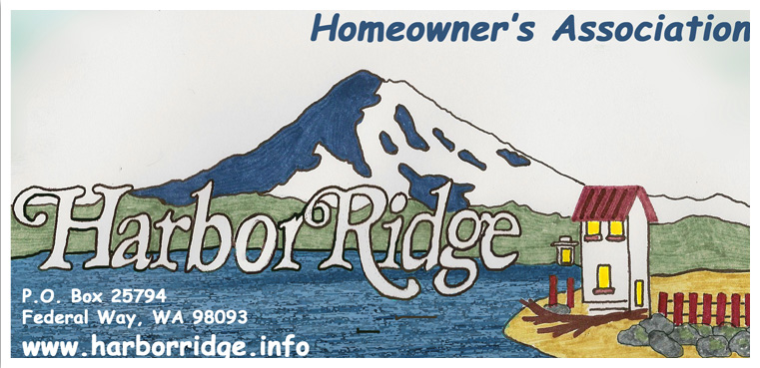

Our annual homeowner meeting is scheduled for Wednesday, 27, January 2016 at 6:00 PM. All homeowners are encouraged to attend. The meeting will be held at the NE Tacoma police substation located at: 4731 Norpoint Way NE Tacoma 98422.

In addition to Board member elections, topics of interest will be discussed along with a general solicitation of ideas for projects your board can accomplish to improve our community.

Winter gloom, rain, wind, and cold are upon us. Our growing season finally petered out but some yard-work is still required to keep our neighborhoods neat and trim. We already weathered two storms and more are on their way. Several fences fell victim to our first fall storms and more may succumb to harsh conditions sure to come. This is a handy reminder to check the condition of your fencing and structures before costly repairs are required.

Large trees are another more dangerous concern. Several were topped, limbed, or removed this summer. This prudent precaution protects both the property owner and neighbors from falling trees and limbs.

If trees are removed or trimmed to improve a view, carefully plan and research what and who’s trees they are before starting your chainsaw! The properties located within our canyons belong to the city of Tacoma or private homeowners. Permission is required to cut, top, or remove trees on city property and is certainly required before any pruning is accomplished on private property.

**COVENANTS, CONDITIONS AND RESTRICTIONS (CC&R’s):**

Our CC&R’s and Bylaws are located on our website: harborridge.info. The board actively perused and cleared several violations this calendar year. Most violations are minor and consist of out of control vegetation, and campers, boats, and trailers stored in plain view.

Covenants and restrictions exist to maintain consistent quality of life in our community. The board attempts to notify homeowners of violations but it the responsibility of individual neighbors to pursue/initiate any punitive actions.

Homeowner projects that may need approval from the Architectural Control Committee, (ACC), include but are not limited to: Reroofing a home, additions to existing homes or drastically changing home color schemes. Before starting your home-altering projects please seek advice from the ACC.

The board may become directly involved in settling CC&R violations once a homeowner initiates a complaint. Remember, individual homeowners are responsible for starting any process to remedy CC&R violations.

One avenue available for homeowners to resolve violations is by requesting compliance with Tacoma Municipal Codes. The most direct way to determine if a Tacoma City code violation exists is by contacting “Tacoma First 311”. Contact them at: 253 591-5000 or through their web site. The easiest way to navigate the internet to their web site is by searching for Tacoma First 311.

**“BE GREEN” OPTION:** Members are encouraged to receive periodic Newsletters by email instead of normal postal delivery. Several members take advantage of this option and we would love to increase that number. To sign up for email delivery, please visit our website at: [www.harborridge.info/](http://www.harborridge.info/)go to the board members menu then enters your request and your email address.

**WEBSITE:** Please visit our website at [www.harborridge.info/](http://www.harborridge.info/). What will you find there? The Harbor Ridge By-Laws, Covenants, Conditions and Restrictions (CC&R’s), board members names, phone numbers and email addresses, Architectural Control Committee (ACC) and much more.

**NEIGHBORHOOD AWARENESS:** At varying times, there are homes in our area that are vacated, for sale, or in foreclosure. Please be particularly aware of homes that are vacated, both for your sake as a neighbor, and in the interest of the owner. If you notice anything unusual, please report it to the owner, and possibly to the police. Both in Northeast Tacoma and in Federal Way, unauthorized individuals have occupied vacated homes.

When you notice your neighbor left his garage door open after dark call and let him know. If it is late and you notice those UPS packages on your neighbor’s doorstep give them a call. If no one is home, take the packages in or hide them. Our local news is full of stories about thieves following UPS trucks and stealing unattended packages! Help your neighbors and our community guard against theft and other crimes.

If you have questions about any police issue, please direct them specifically to the police department’s Community Liaison Officer (CLO) for our area Officer Brandon Showalter at 253-594-7951 or Brandon.showalter@cityoftacoma.org.